**FoodBox Application - Phase 6**

## **Github Main Url** -

## **Table of contents**

* General info
* Programming and deploying the application
* Technologies
* How to run the program locally
* Using the application

## **General info**

This project aims to design and develop an E-commerce website that lets people shop food items of different cuisines at affordable prices and deliver the products to their addresses. It was developed using Angular and Spring boot for the Full Stack Java Developer course as capstone project.

**Programming:**

* Create database and tables.
* Add some rows and metadata to the tables
* Initialize a Spring Boot project for the Back-End side.
* Create REST APIs with spring Data JPA Repositories.
* Create desired DAO methods for the Back-End side
* Create a new Angular project for the Front-End side.
* Create login and register pages and components.
* Add cache to the login user
* Logout user and remove cache
* Show all products to the home page.
* Show all products as cards.
* Create a product details component.
* Search a product by a category.
* Search a product by a keyword.
* Add products pages
* Filter by page number

**Deployment:**

* Upload project to GitHub. For jenkins, two separate Github repositories are used for frontend and backend.
* Install Jenkins in the windows as a service.
* Configure all the tolls such as maven, java, git and nodejs globally available by setting the proper system and environment variables or by configuring in jenkins.
* For github integration, two separate repositories has been created since we need to create two jenkins freestyle project.

<https://github.com/SathishSubramanian96/FoodBox_backend.git>

[https://github.com/SathishSubramanian96/FoodBox_Frontend.git](%20%20%20%20%20%20https://github.com/SathishSubramanian96/FoodBox_Frontend.git)

* Starting with jenkins, we need to create two freestyle projects with the following windows batch command for backend,

**call git ' https://github.com/SathishSubramanian96/FoodBox_backend.git'**

**call mvn clean install -DskipTests**

**call mvn spring-boot:run**

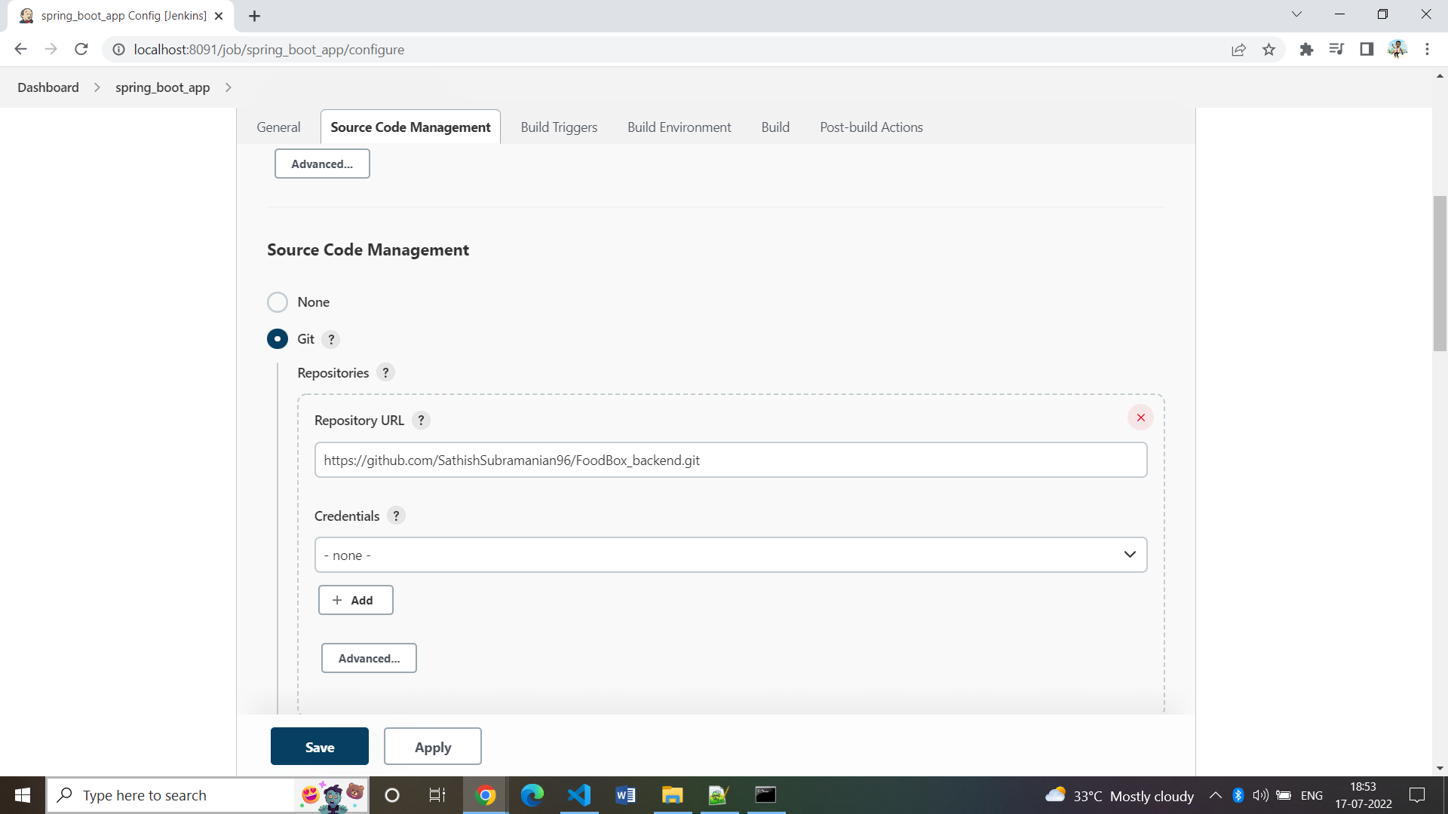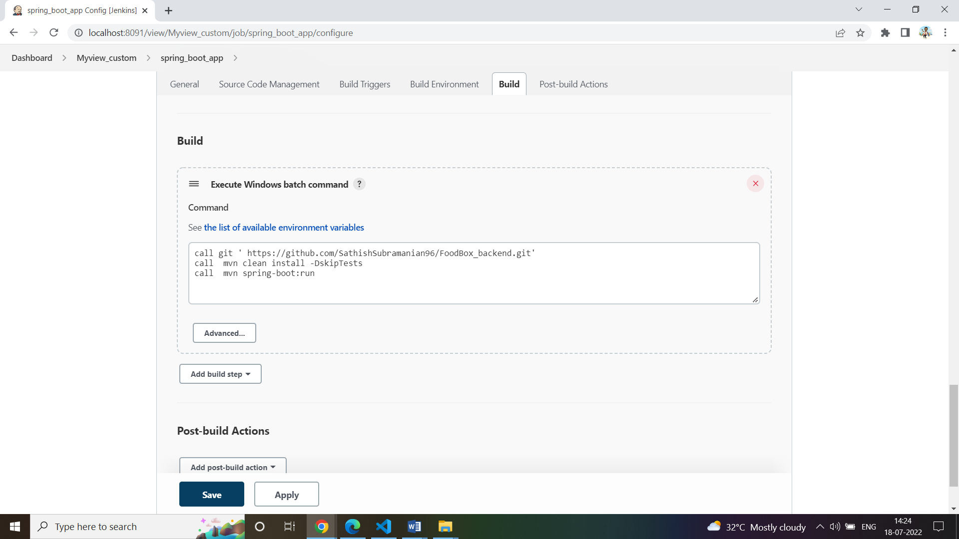

* Next we need to create another freestyle projects with the following windows batch command for frontend,

1. **Npm install**
2. **Npm run start**

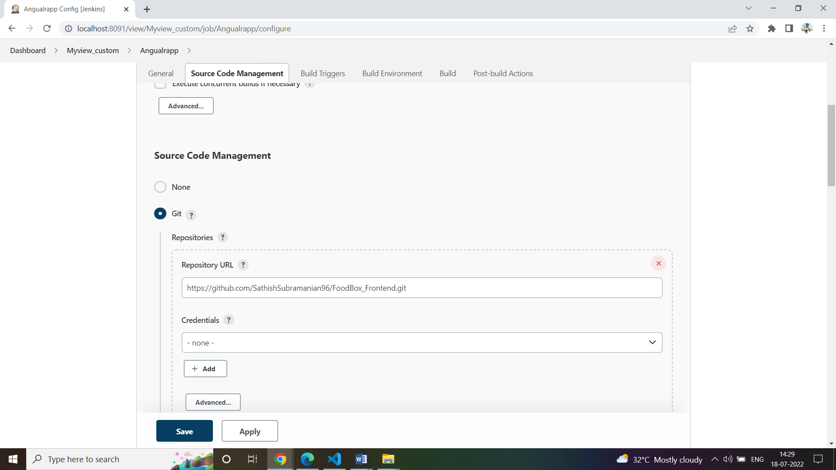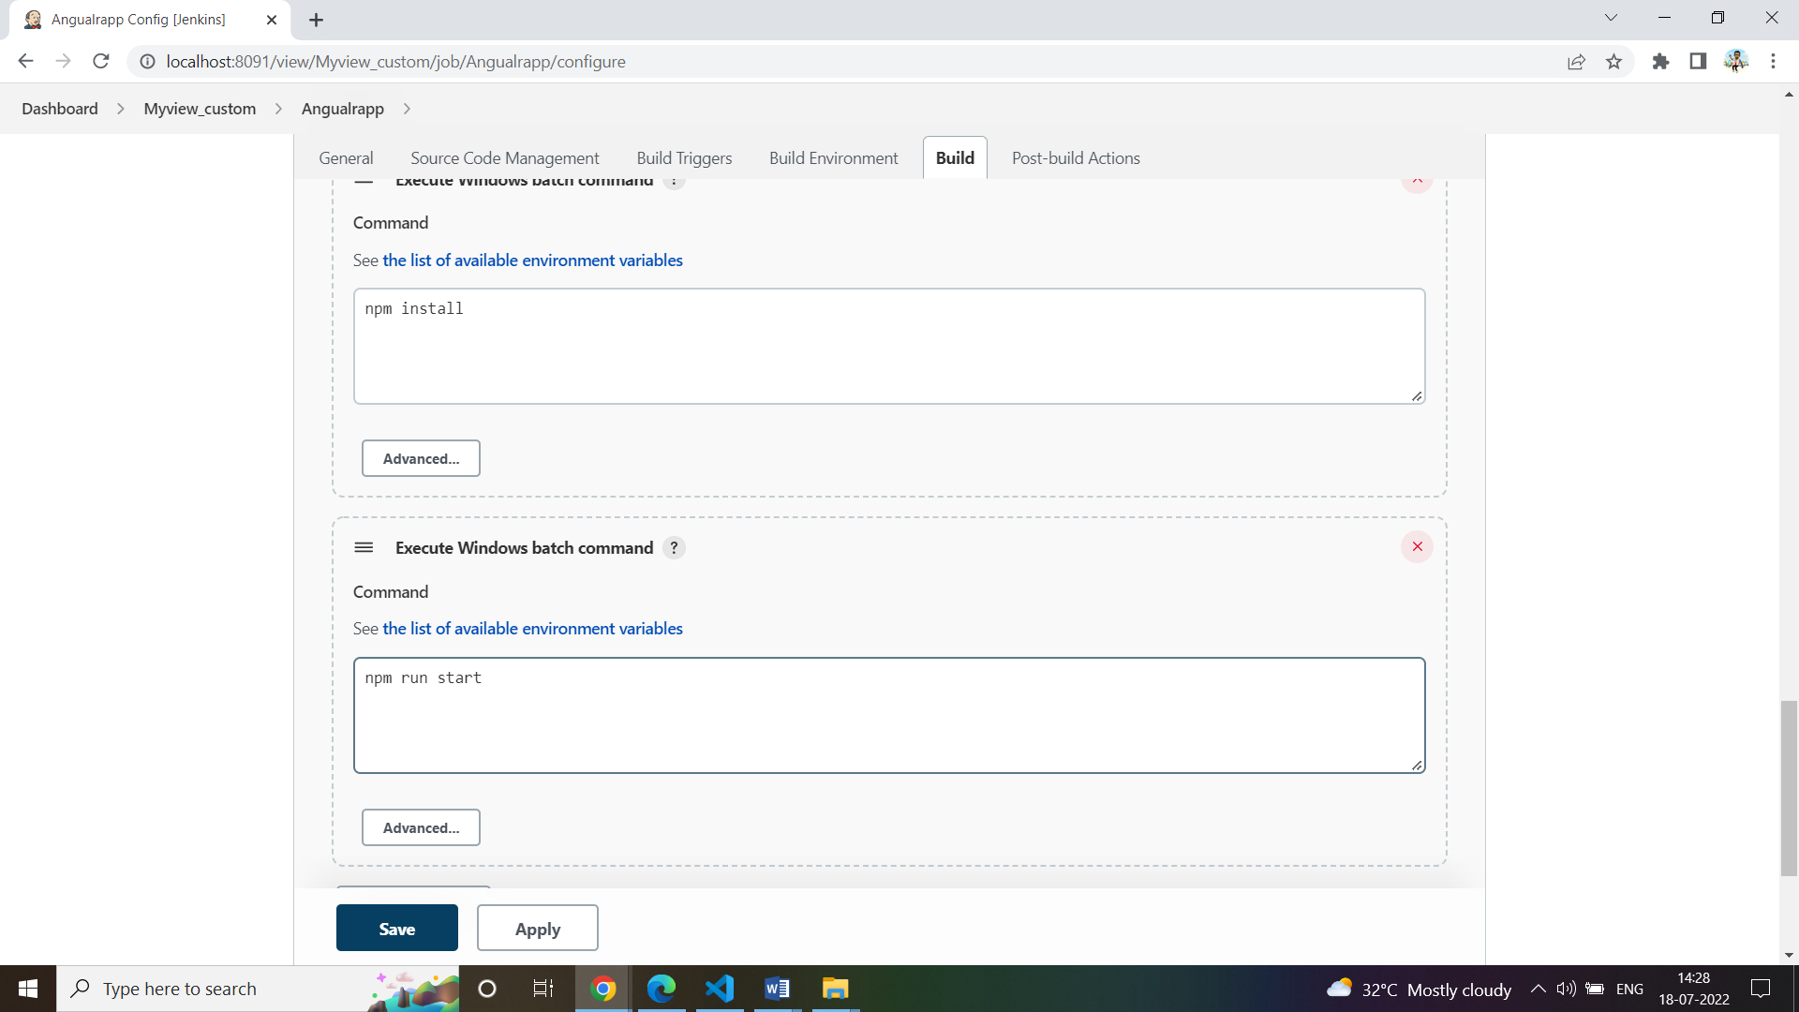

* Now we can run both the jobs simultaneously and we can check the application though the following url- <http://localhost:4200/>

## **Technologies**

* **Spring Boot:** used in the back-end side to create the REST API and retrieve data from a database.
* **AWS RDS:** to upload the database online.
* **Jenkins:** to build the project from GitHub.
* **GitHub**: to upload the source code of the project.
* **Selenium:** for automation and testing.
* **HTML/CSS**: to create and format the content of the pages.
* **Bootstrap**: to use some CSS and JavaScript designs.
* **Maven**: to manage the project.
* **Visual Studio Code**: to write and run the Angular code.
* **Eclipse**: to write and run the Spring Boot code.
* **MySQL**: to use it as database management system.

**How to run the program locally**

* Clone project
  + clone git : git clone <https://github.com/MujtabaMohsin/Foodbox>
* Import the “\Back-End\foodbox\database\foodbox.sql” file to your database administration tool.
* Go to “\Back-End\foodbox\src\main\resources\application.properties” file, open it.
* Edit some values of the database’ properties to be suit to your database administration tool(for localhost).
* Run the back-end project as a maven project:
  + cd to your project “Back-end\foodbox”
  + mvn compile -Dskiptest
  + mvn exec:java -Dexec.mainClass=com.simplilearn.foodbox (or)
  + mvn spring-boot:run
* Open another command line for the front-end part.
* cd to your project “Front-end-end\foodbox”
* Install the following:
  + npm install --save-dev
  + npm install @angular/localize --save
  + npm install bootstrap --save
  + npm install font-awesome –save
* Run using ng serve –open
* It would be displayed in <http://localhost:4200/>

**Using the application:**

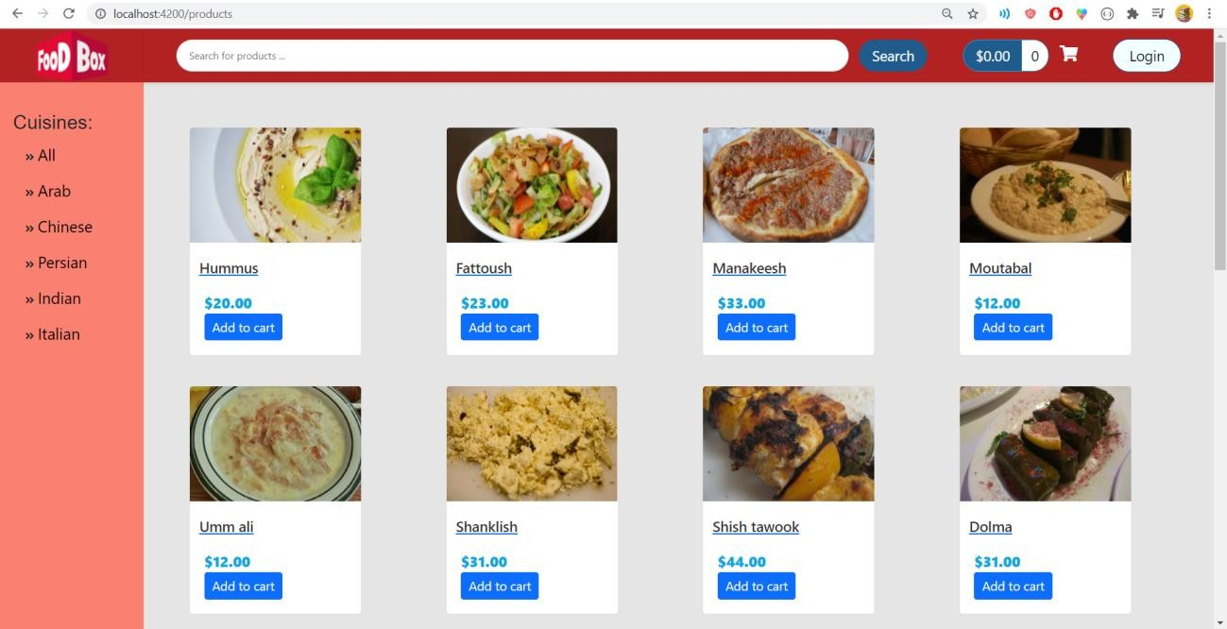• General look of the store:

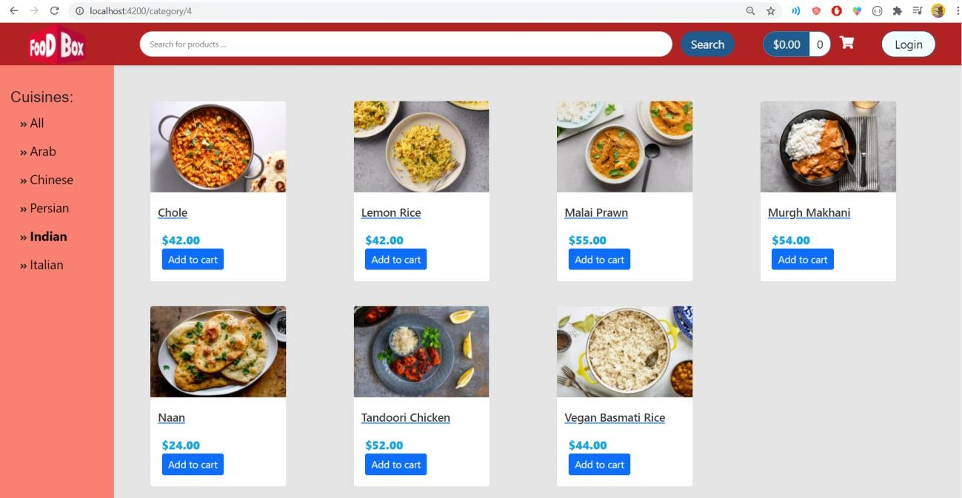**•** Filter the product according to the cuisine

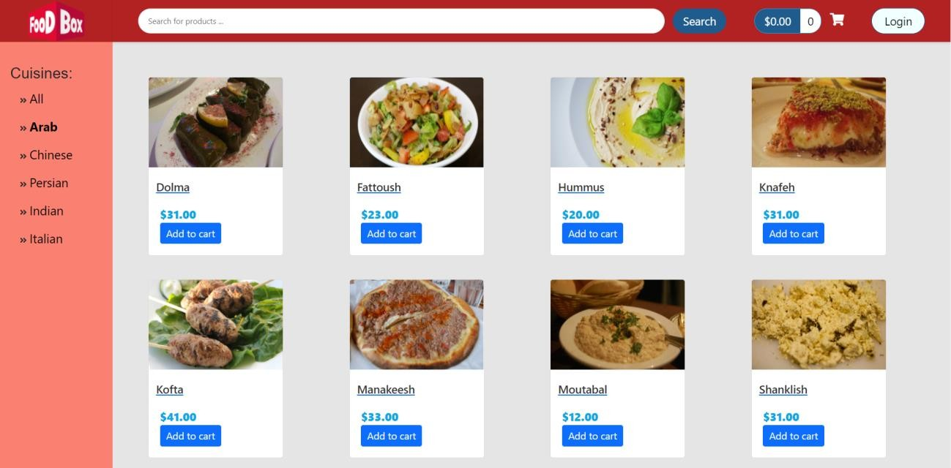

• Filtering by page and sorting are available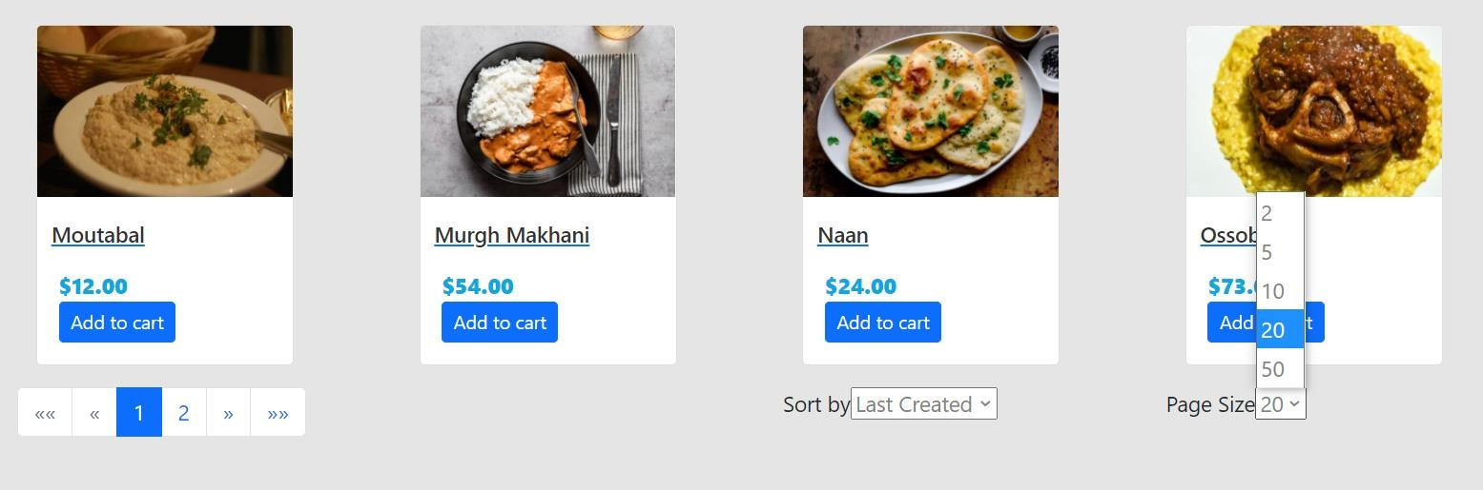

• Sorting can be in one of these three options

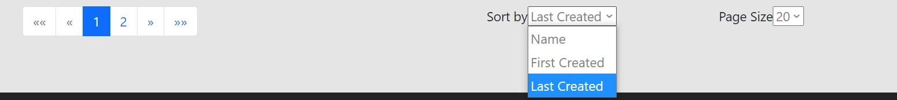

• Sorting by name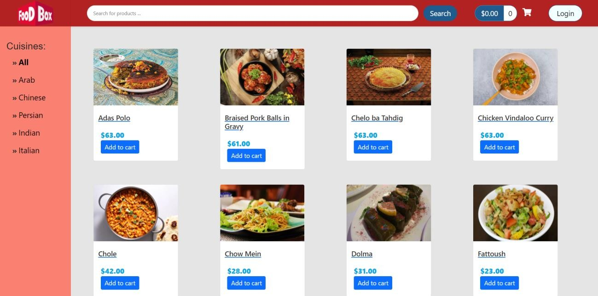

• Choosing the number of each displayed products in each page

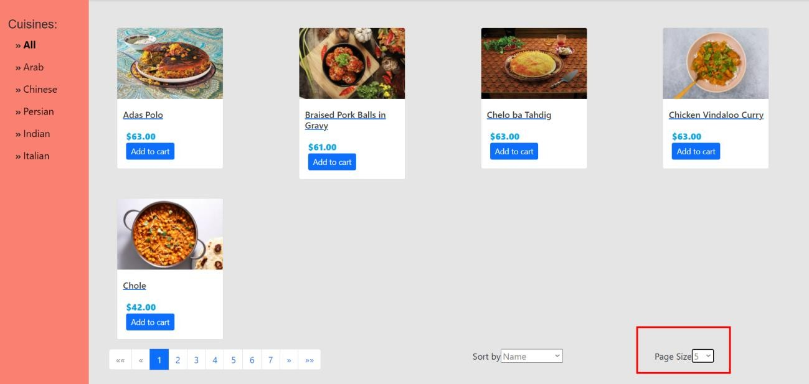

• You can add products to the cart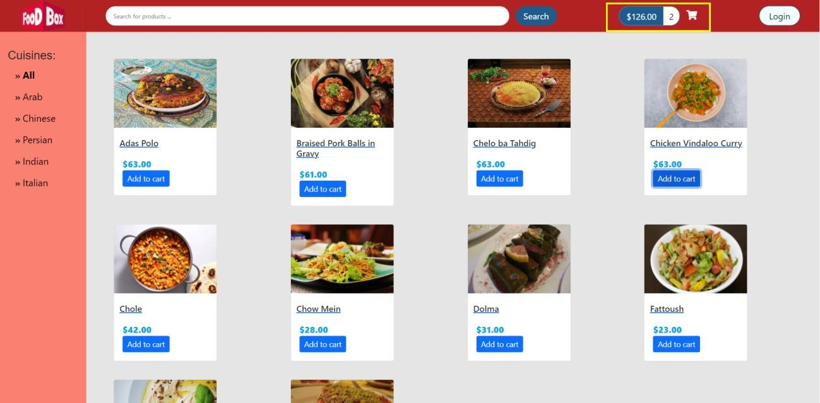

• However, you need to be registered to buy

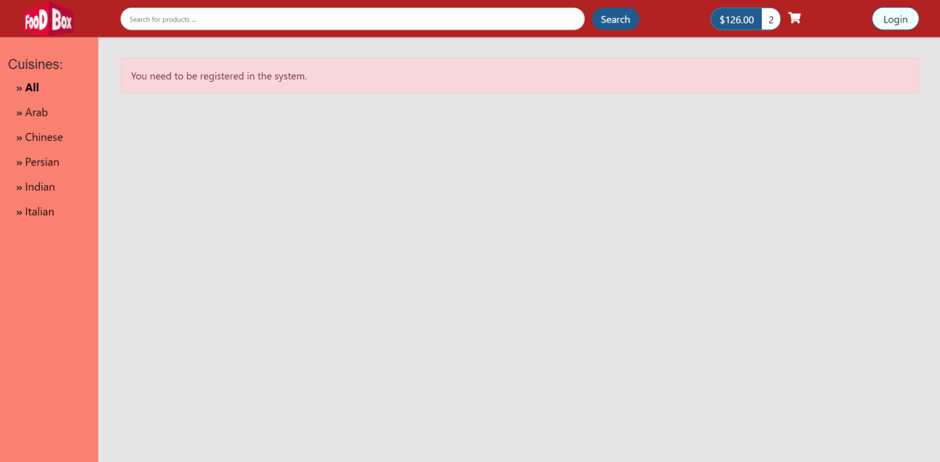

• Login and then create account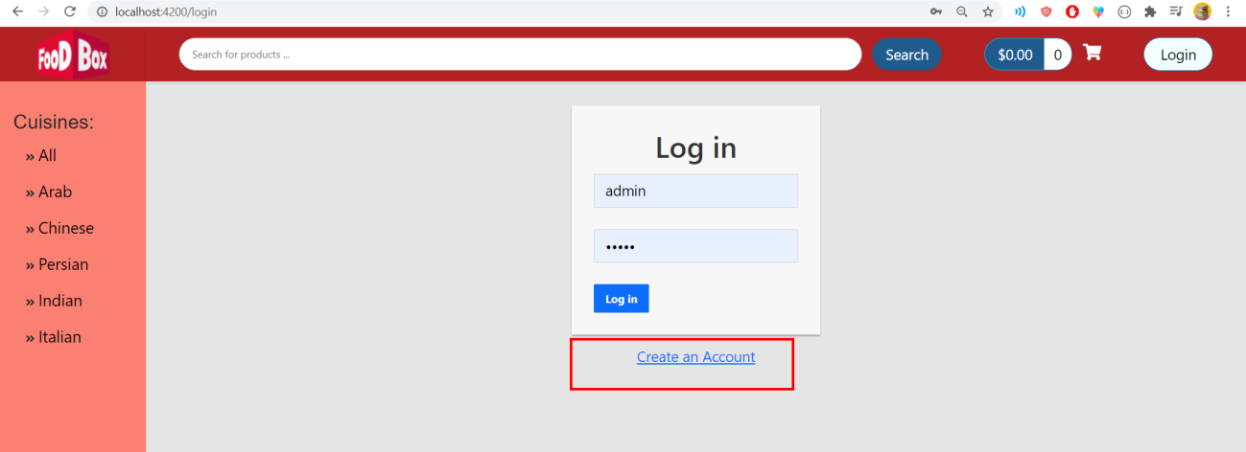

• Register form

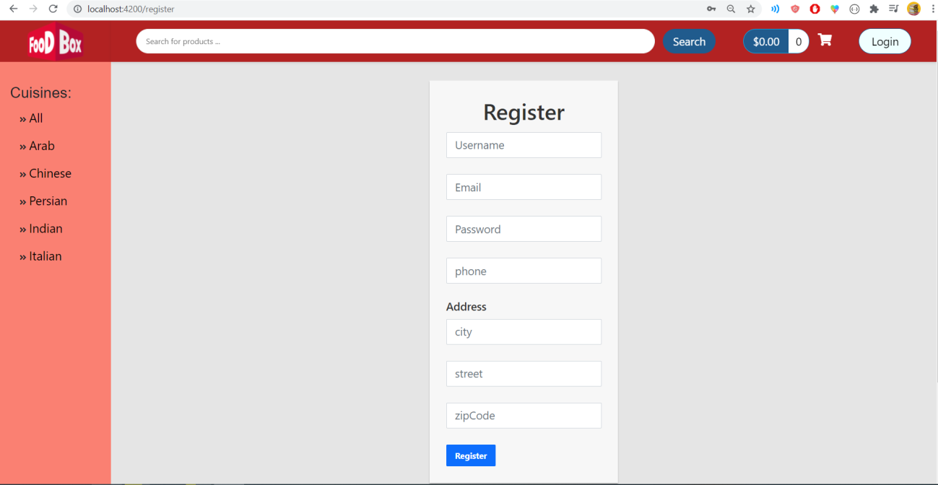



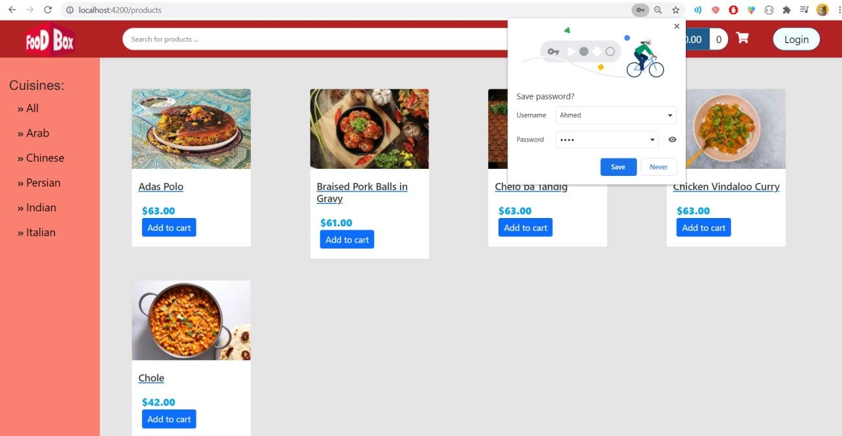

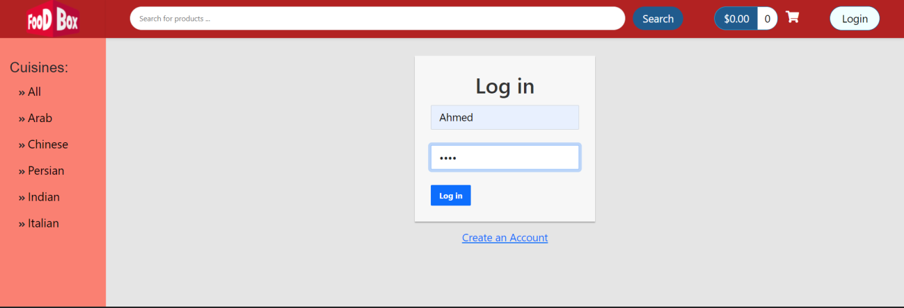

• User signed in to the application.

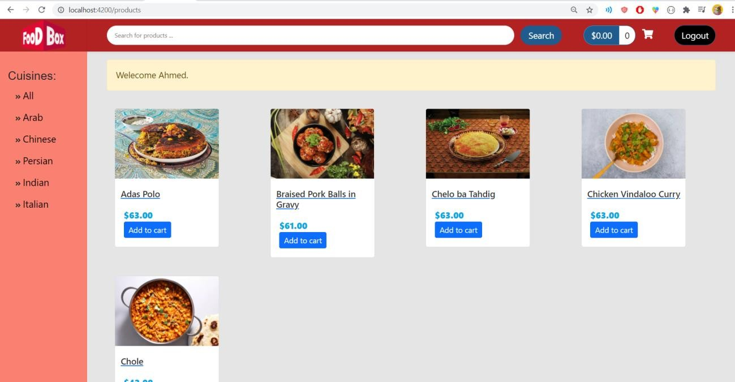

• User can now buy (Payment gateway)

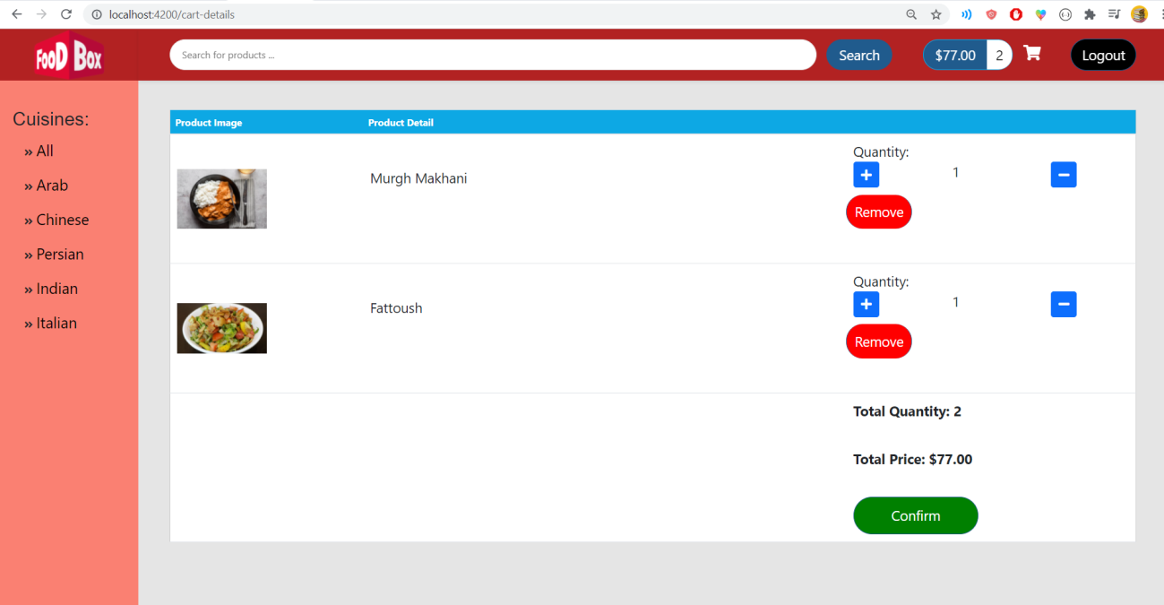

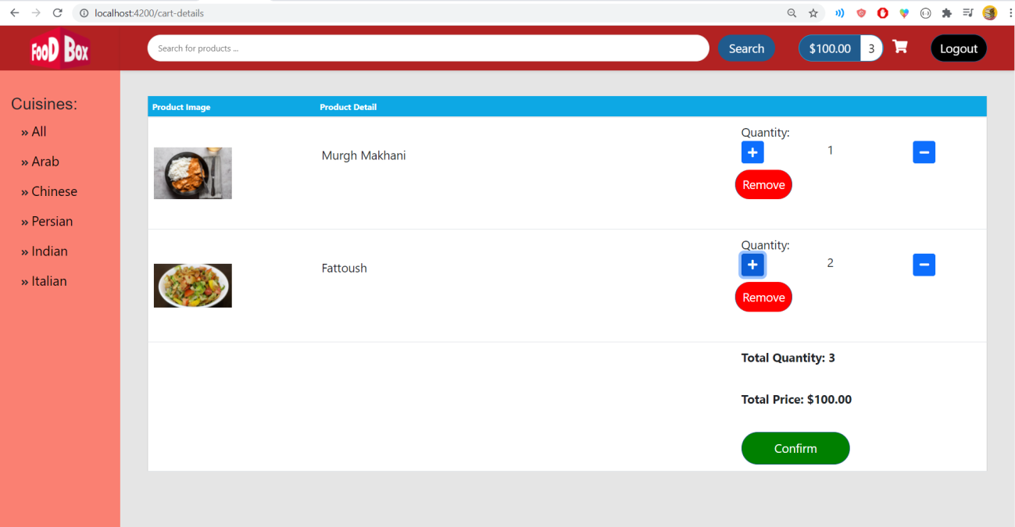• Can add/remove products during review

• Check-out and confirm

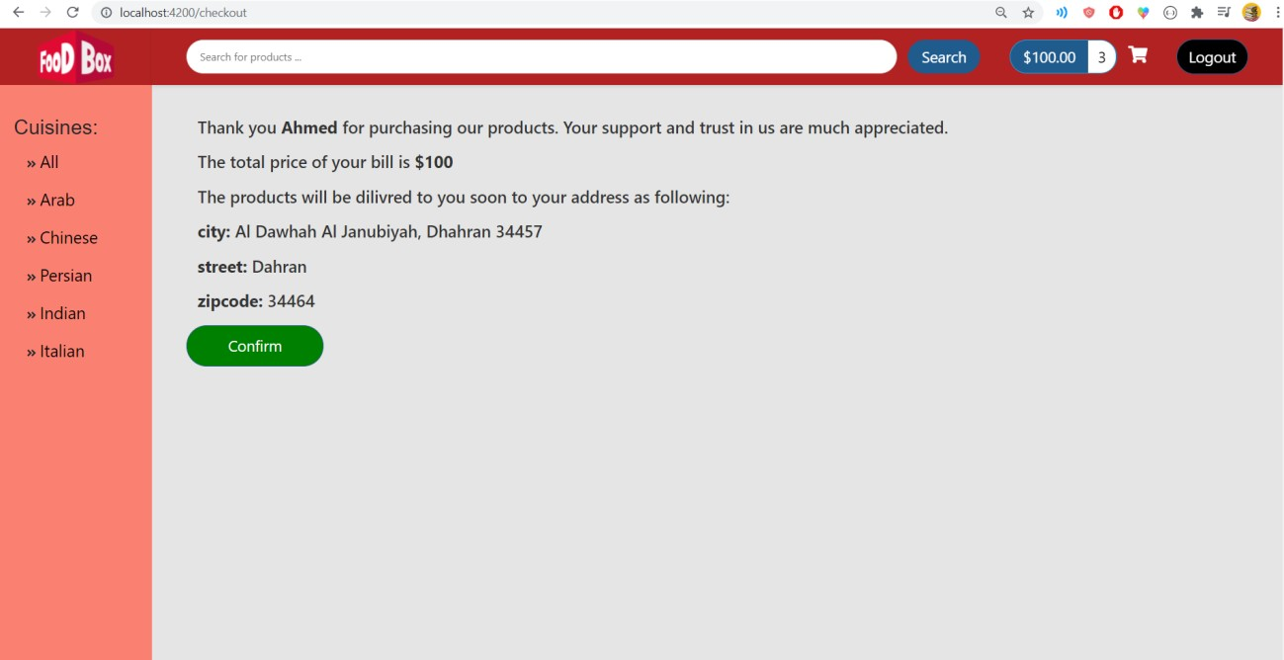

• Search products by Name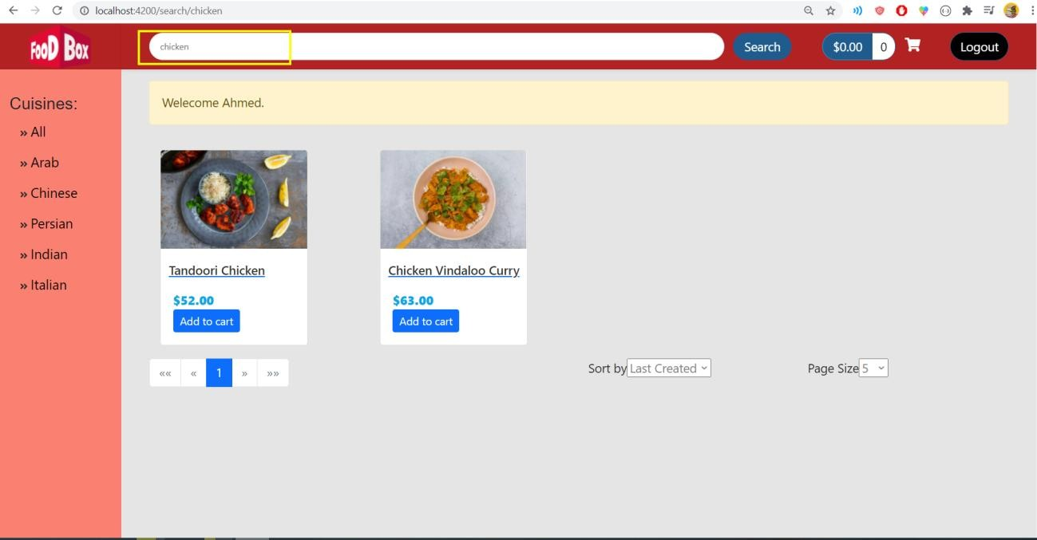

• Now, let’s log in as admin

• Admin/admin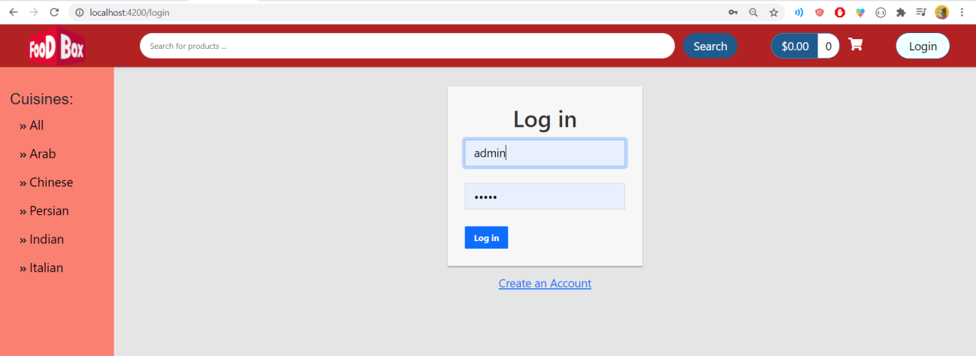

• Admin can:

* Create product
* Edit product
* 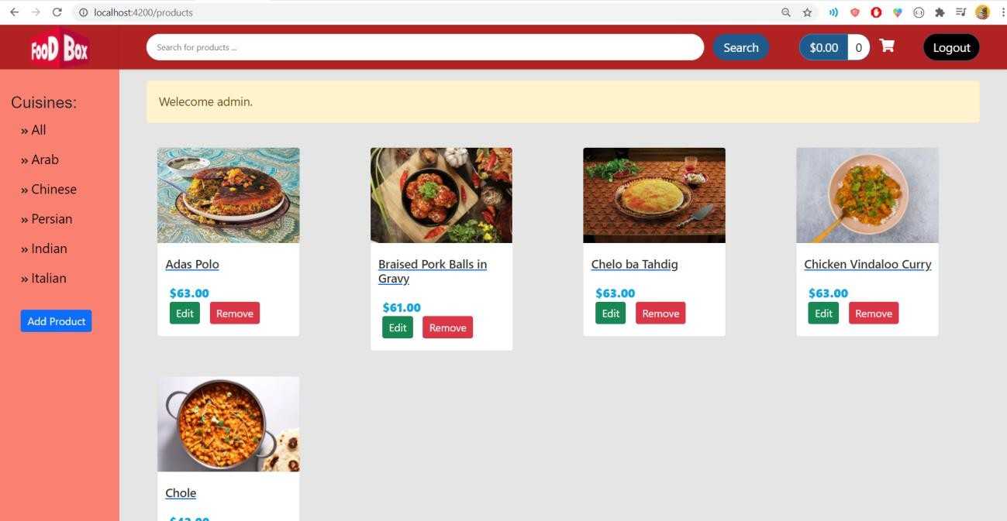Delete product

• Create a new product

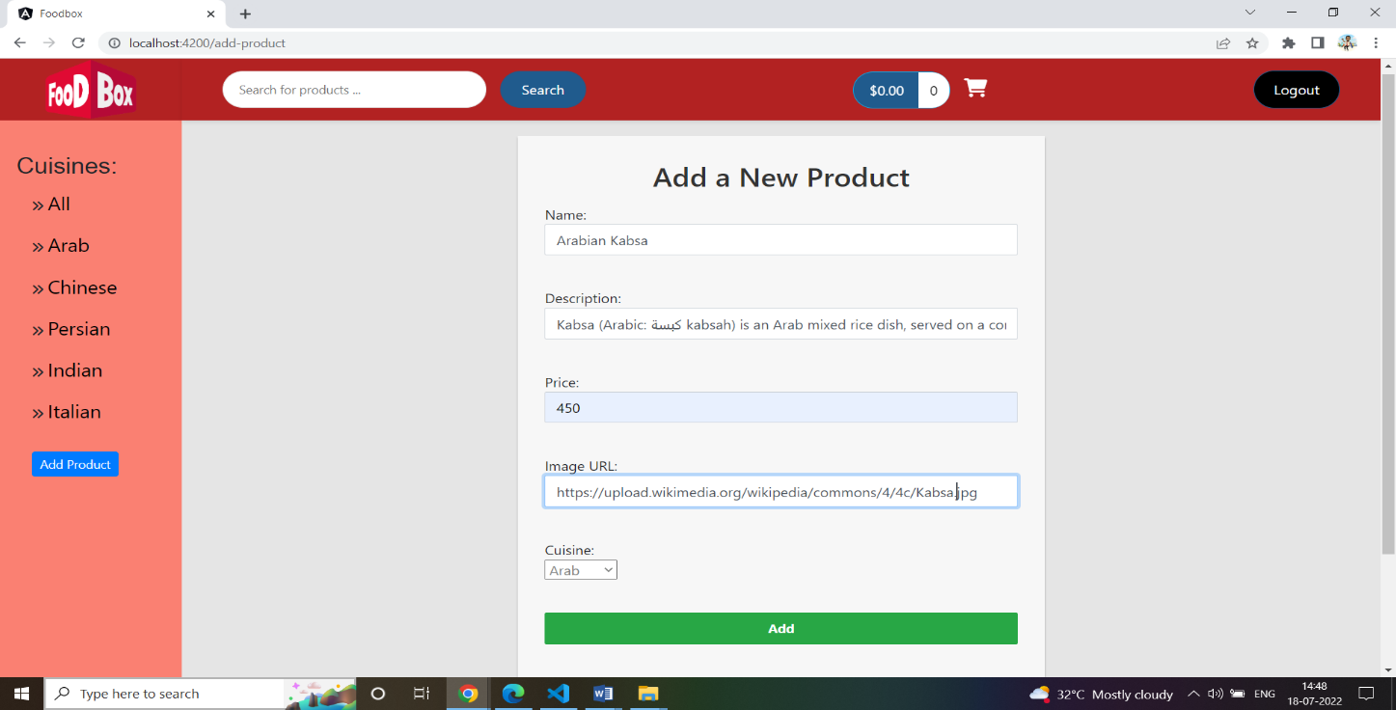

• The new product was added

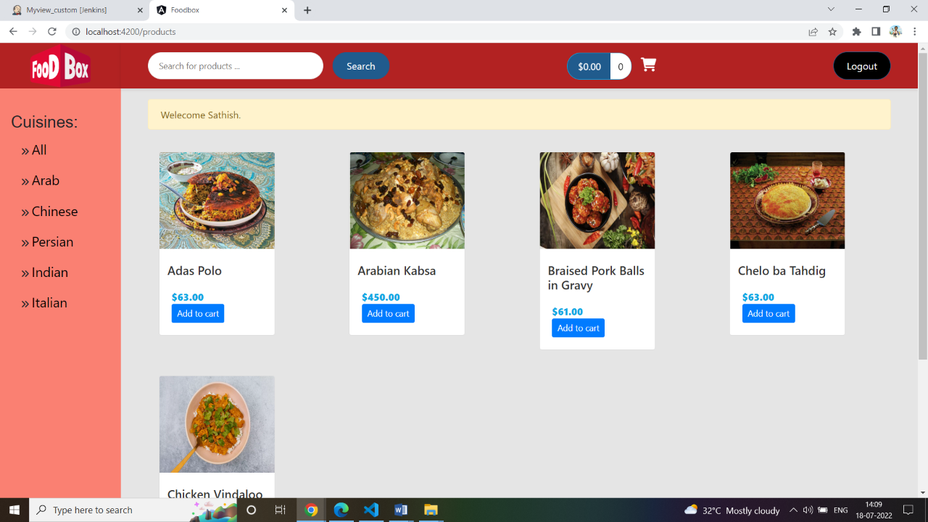

• Let’s update it

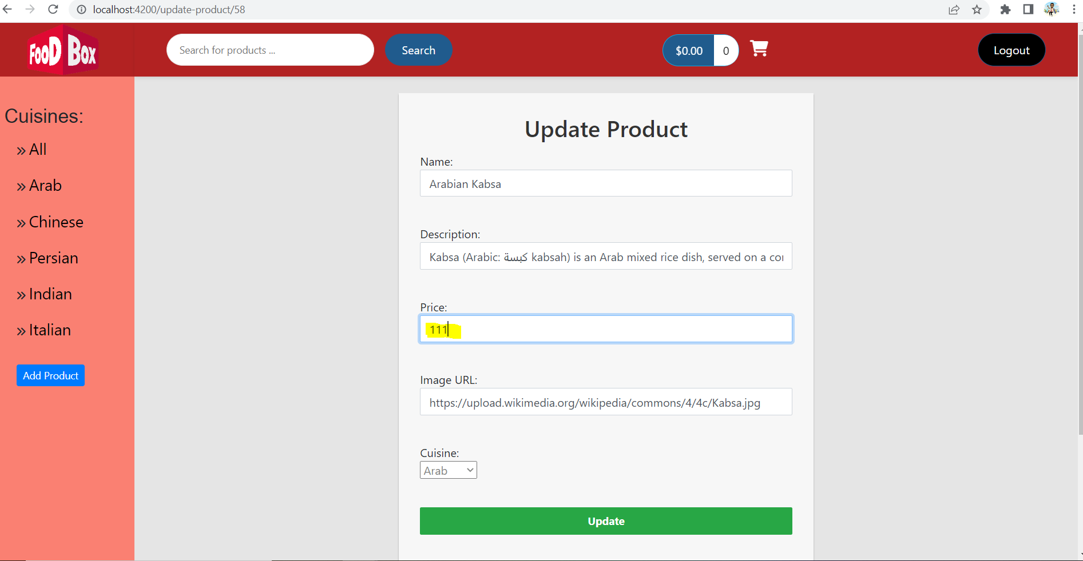

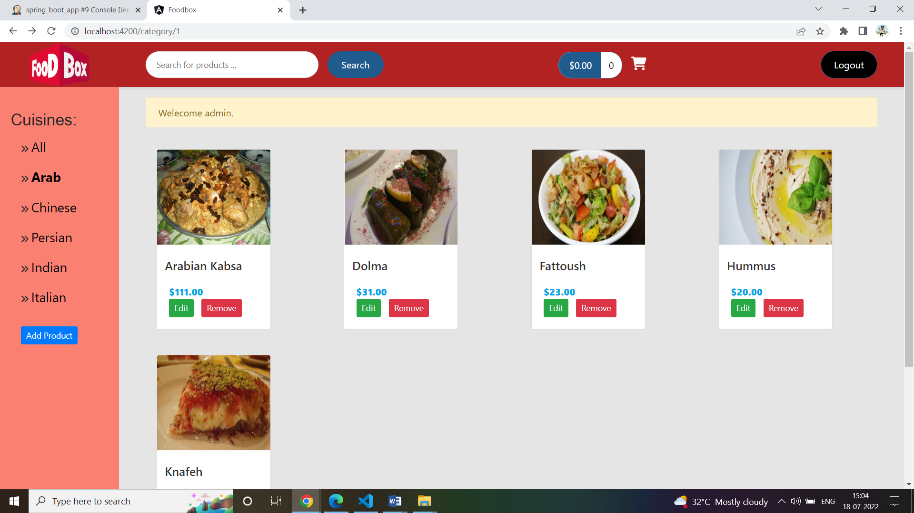

• Click Remove to remove it

